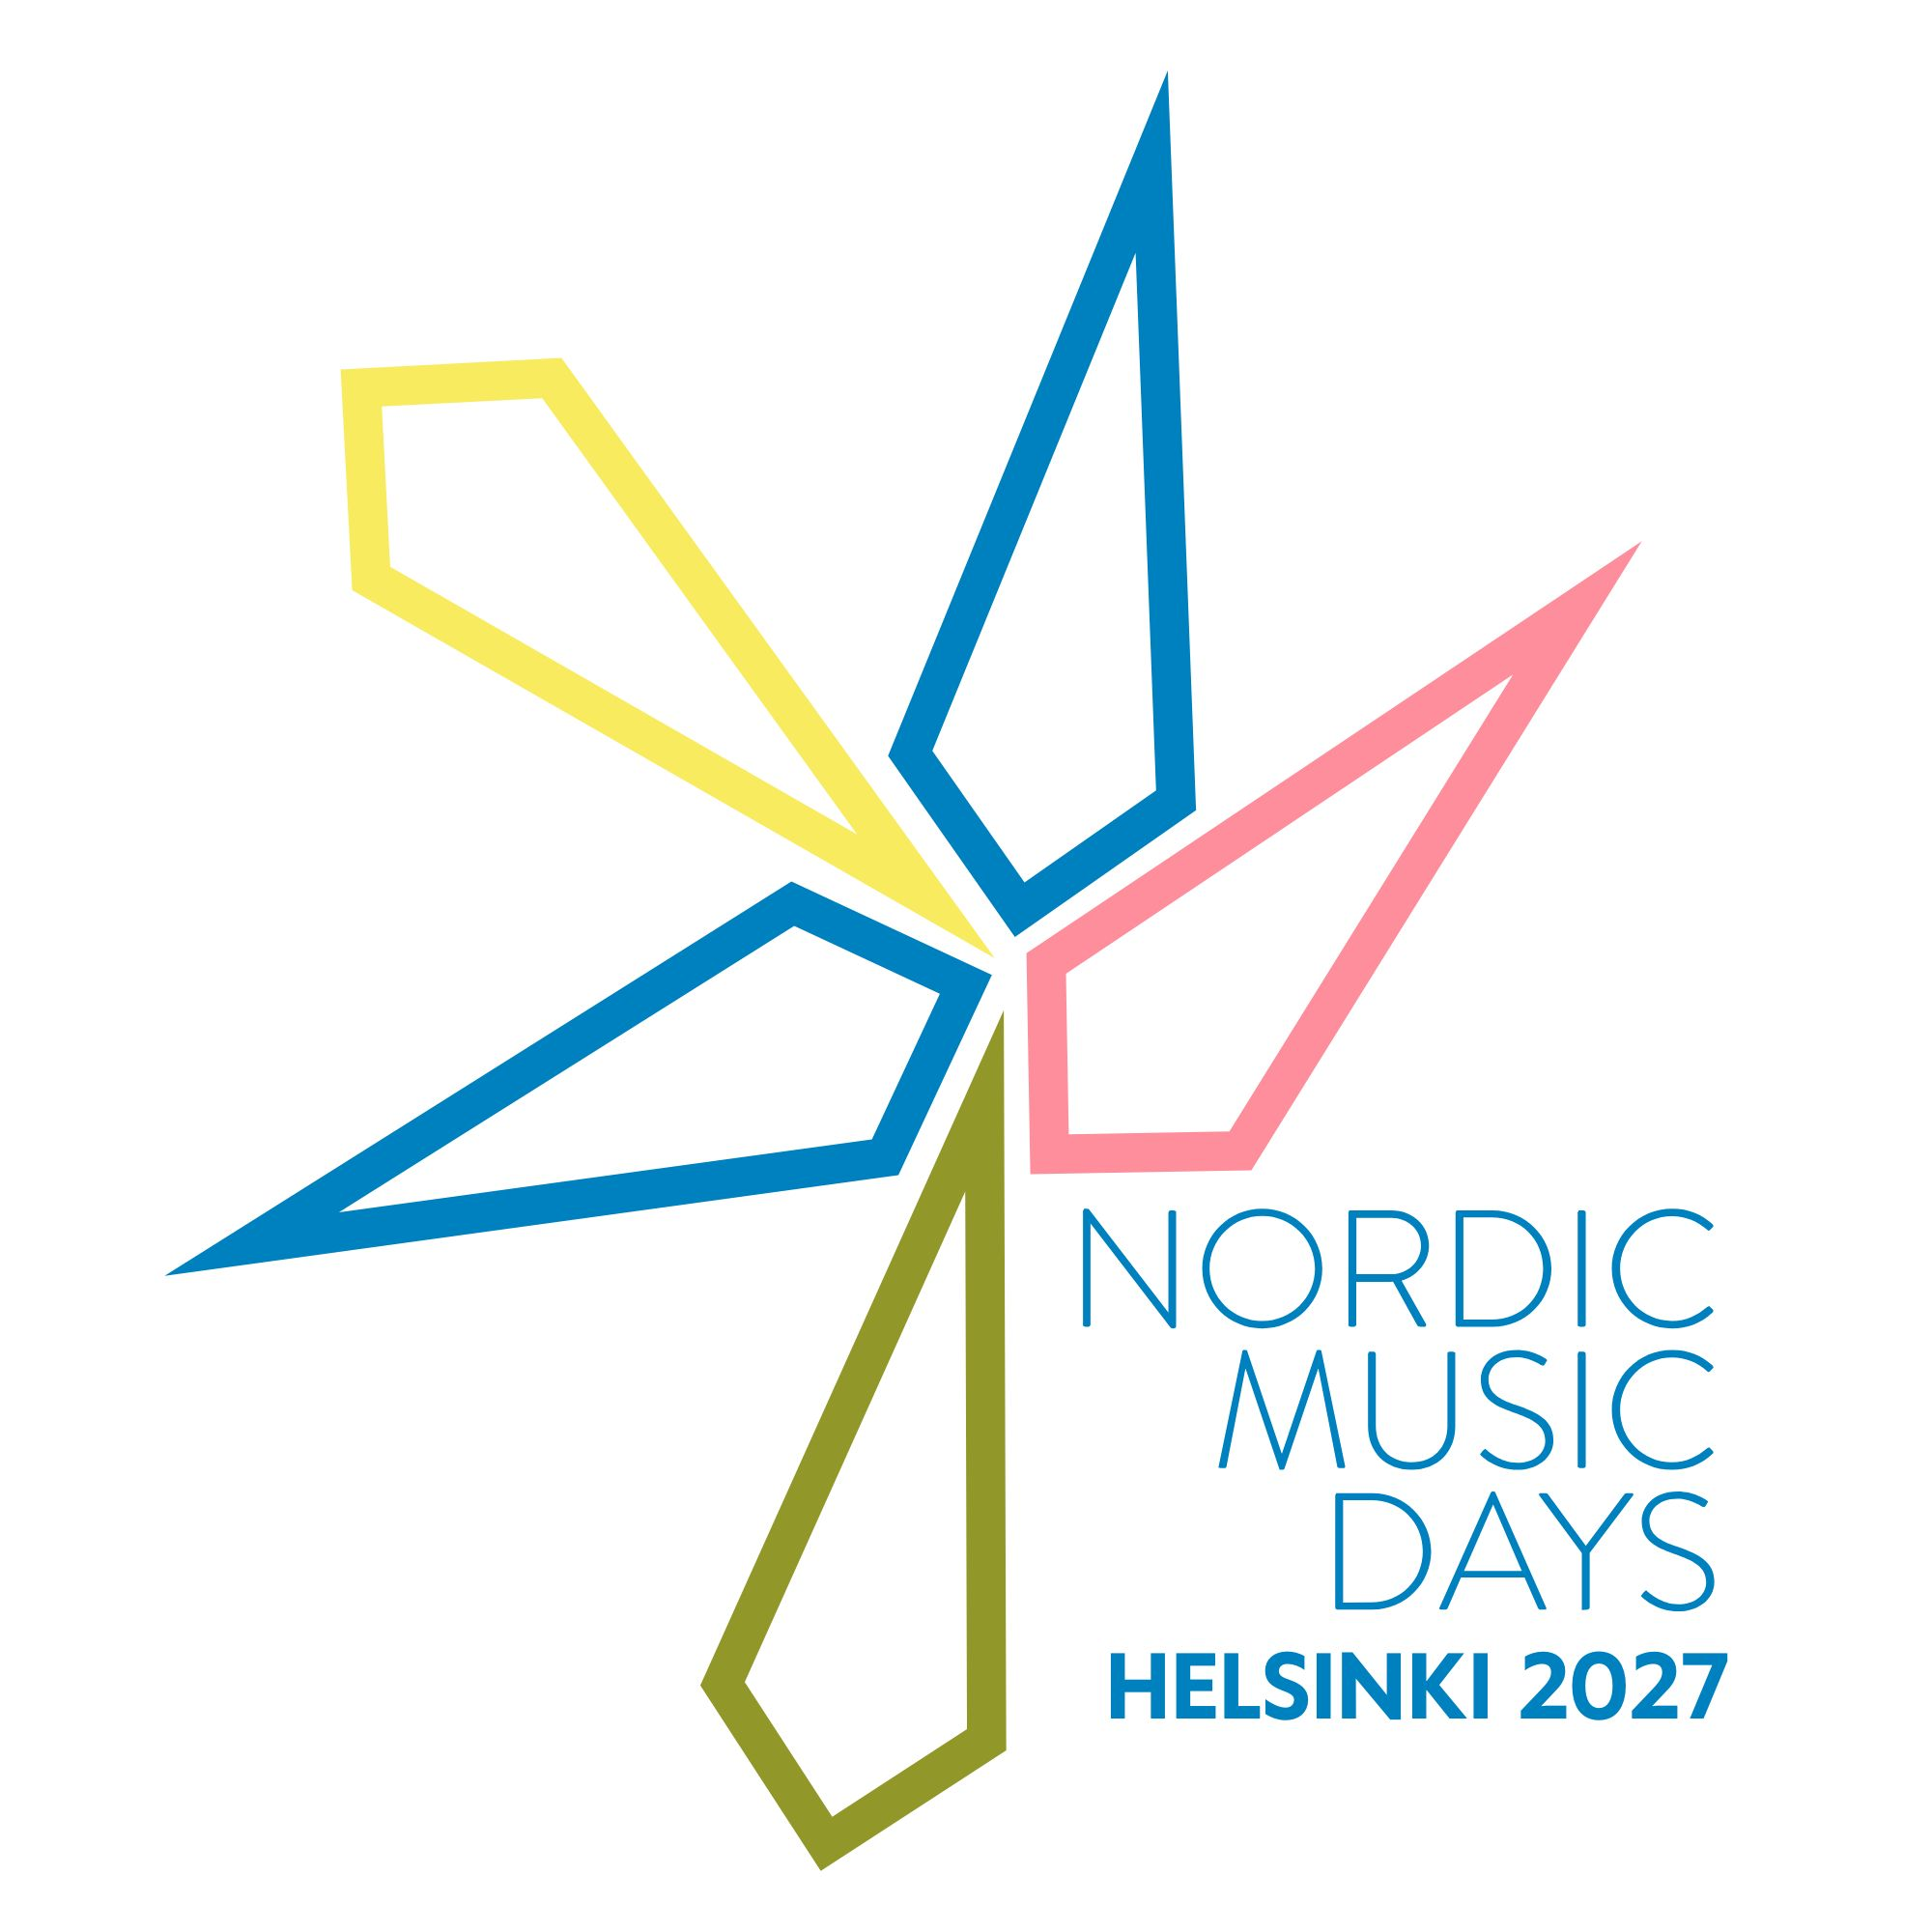

OPEN CALL: Nordic Music Days 2027

Invitation to apply from the NMD 2027 Curator Team
How are you?
What are you up to?
What are you making and what are you passionate about?
Nordic Music Days returns to Helsinki in November 2027 and we would like to invite you to make a submission to the open call.
We are curious about where contemporary sound and music are at these days, and where we are heading. We would like Nordic Music Days to be a place for different forms of sound practices, and our wish with this call is to have a festival that echoes what’s going on in the scene across the Nordics, Baltics and Scotland. We in the curating team want to invite you to Nordic Music Days as a place for listening, somewhere to meet new music and new friends; to be welcomed and inspired.
The call is designed with six categories and we hope one of them fits the work you’d like us to hear. Get in touch if you’re not sure!
We are ready to listen and looking forward to hearing your work!
David Fennessy, Jana Winderen, Juhani Nuorvala, Kajsa Antonsson, Þráinn Hjálmarsson
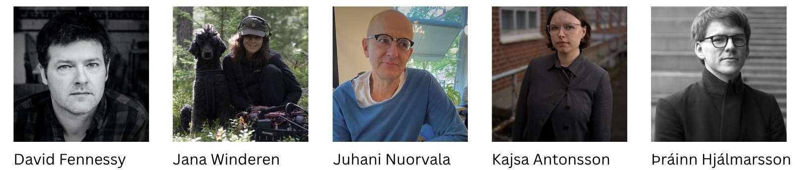
The Nordic Music Days 2027 Curator Team
Contents:
- About the open call
- The six call categories
- Eligibility and selection criteria
- How to apply
- Support for submitting your work
- About Nordic Music Days 2027
- Submissions checklist and key dates

About the open call
Nordic Music Days 2027 invites composers and artists from the Nordics, Baltics and Scotland to submit a single work to one of the festival's six open call categories. The festival will take place in Helsinki from 10 to 13 November 2027, with one day in Tallinn in association with Baltic Music Days on 11 November.
The deadline for submissions, via our digital submission platform is by the end of the day on Monday 24 August 2026. Applicants can expect to hear by Monday 21 December 2026.
For information, help and advice on the open call, please contact either Rachel Faulkner, Project Manager rachel@nordicmusicdays.org, or Petra Piiroinen, Producer petra.piiroinen@composers.fi
Please note that Petra and Rachel will be on leave and unable to respond during the following times: Petra 29.6 - 24.7. Rachel 06. - 31. 7.

The call categories
There are six open call categories for existing works. Please submit your work to a category you find most fitting.
1 Artists | For artists with sound based practices, musicians, composers, groups or ensembles who perform their own works. You can apply with a performance, a work, a set or a production.  Information requested:  - PDF drawings/ images, sound/ video excerpt, technical requirements (as relevant to the work)  - Short programme notes/ description (150 words), or 90 second max audio/ video description, or max 3 slide presentation
2 Electronic and acousmatic works | The festival will be able to provide at least an octophonic ring plus centre front, back and sub, along with a suspended ring of 4 above the audience and ring of 4 on the floor. There will also be the possibility of an in-fill pair of speakers upstage.  There is as well the potential for live electronics with acoustic instruments, loudspeaker ensemble, and creator/ performer works - see category one, call for artists and category three, ensemble.  In each case, the creator will be consulted on the tech specifications to prepare the presentation.  Information requested:  - PDF Score (if relevant), sound/ video excerpt, technical requirements  - Short programme notes/ description (150 words), or 90 second max audio/ video description, or max 3 slide presentation
3 Ensemble works, acoustic and electroacoustic | Works for instrumental ensembles, vocal ensembles, and small groups, and solo works. May include organ, electronics, digital instrumentation and video. Participating ensembles could include (but are not limited to):  - Avanti! A 26-member 2222 2122 2211 perc harp gtr pno, with conductor  - defunensemble fl, cl, pno, vcl + 2 technicians, without conductor. Specialised in electroacoustic music  - Uusinta Ensemble 2vl, vla, vcl, fl, cl, 2sax, 2pno, without conductor  - Nyky Ensemble (Sibelius Academy’s students – varied instrumentation period to period)  - Helsinki Chamber Choir chamber choir up to 24 singers, with conductor  - Twenty Fingers Duo vl, vcl  - Perons Percussion, perc, up to 10 members, without conductor (please contact Rachel if you require further details)  If you have works that can only be performed by a specific performer or ensemble, you can apply with that in this category.  Information requested:  - PDF Score, sound/ video excerpt  - Short programme notes (150 words), or 90 second max audio/ video description, or max 3 slide presentation
4 Installations and sound based works | Installations suitable for indoor and outdoor spaces, including site and context specific installations. For example:  - Self-contained installation works  - Performative or interactive installations  - Durational performances  - Soundwalks or listening projects  - Podcast or radio  - Conceptual sound related works  Information requested:  - PDF drawings/ images, sound/ video excerpt, technical and/ or spatial requirements  - Short programme notes/ description (150 words), or 90 second max audio/ video description, or max 3 slide presentation
5 Orchestral works to be performed by the Estonian National Symphony Orchestra at the Estonia Concert Hall. | Orchestration: symphony orchestra, maximum size 3.3.3.3 - 4.3.3.1 - 3 perc - 1 timp - hp – strings 14-12-10-8-6. Proposed works could include electronics (excluding video) and/or a soloist. Please note that the Estonia Concert Hall stage has limited space for percussion and/or electronics.  The use of electronics is permissible but in a limited capacity due to technical and space restrictions in the hall. You can be in touch with Petra Piiroinen (petra.piiroinen@composers.fi) with questions about feasibility of your work’s technical needs.  The theme of the Baltic Music Days is 'The Pressure of the North Star'. If you wish, you may indicate that your piece relates to this theme. Four to five pieces will be chosen in total from the Nordics, Scotland and Baltics.  Information requested:  - PDF Score, sound/ video excerpt  - Short programme notes (150 words), or 90 second max audio/ video description, or max 3 slide presentation
6 Self-produced cinema works | For music makers expanding their practice into filmmaking and self-produced short films.  Information requested:  - Film excerpt or link for viewing  - Short programme notes (150 words), or 90 second max audio/ video description, or max 3 slide presentation

Eligibility and selection criteria
We welcome one submission to one of the six categories from all composers and artists living in, or from, Åland, Denmark, the Faroe Islands, Finland, Greenland, Iceland, Norway, Sápmi, Sweden, and Scotland. We welcome one submission to category 3 Ensemble or category 5 Orchestral from all composers living in Estonia, Latvia and Lithuania.
Existing works must be from 2017 or later. Submissions should be in English – please contact the composers society in your country if you require help with this.

The Curator Team will review all submissions and make selections based on creating a balanced diversity of featured works, composers and artists.

How to apply
Submit through our digital platform at http://nmdsubmission.org/
- Create a user account (or login if you have previously registered)
- Enter (or edit) your profile information
- Create a new submission
- Choose which category you are submitting to
- Enter information on your work. You can choose to provide programme notes/ description (maximum 150 words), or provide information on your submission via audio/ video (maximum 90 seconds long), or slides (maximum 3 slides)
- Upload supporting documentation as requested in the call category: e.g., the score/installation drawings as a PDF file, sound/ video excerpts
Live or studio recordings (audio/ video) are preferred, but not required. Direct links can be included.

Consent and conditions
During the submissions process you will be asked for consent to:
- Share your submission with the 2027 curator team and use your information to contact you about your submission
- Archive recording, broadcast/ streaming and sharing excerpts on social media if successful

It is an expectation that all selected works will be registered with the relevant collecting society by the creator.

Support for submitting your work
If you have any questions about Nordic Music Days or the call process, or if we can help you in any way to ensure you can access this opportunity please contact either: Rachel Faulkner, Project Manager rachel@nordicmusicdays.org, or Petra Piiroinen, Producer petra.piiroinen@composers.fi
For technical assistance with the submission system e.g. log-in not working, please contact Rachel.
Please note that Petra and Rachel will be on leave and unable to respond during the following times: Petra 29.6 - 24.7. Rachel 06. - 31. 7.
There will be two online question and answer sessions with Rachel, Petra and members of the Curator Team where you can find out more about the calls, ask questions and meet other composers and artists. The meetings will be in English and booking is required.
On Friday 14 August you can meet Kajsa Antonsson from the Curator Team. Book here by Thursday 13 August. The meeting takes place at:
- 9 – 10.00 WGST (West Greenland)
- 11 - 12.00 GMT/ EGST (Iceland/ East Greenland)
- 12 – 13.00 WEST/ BST (Faroe Islands/ Scotland)
- 13 – 14.00 CEST (Norway/ Denmark/ Sweden)
- 14 – 15.00 EEST (Åland/ Finland/ Estonia/ Latvia/ Lithuania)
On Monday 17 August you can meet Þráinn Hjálmarsson and Juhani Nuorvala from the Curator Team. Book here by Friday 14 August. The meeting takes place at:
- 15 – 16.00 WGST (West Greenland)
- 17 - 18.00 GMT/ EGST (Iceland/ East Greenland)
- 18 – 19.00 WEST/ BST (Faroe Islands/ Scotland)
- 19 – 20.00 CEST (Norway/ Denmark/ Sweden)
- 20 – 21.00 EEST (Åland/ Finland/ Estonia/ Latvia/ Lithuania)
For assistance with translation to English, converting files or scanning scores, please contact the national composers’ society in the country you are living in, or from.

Contact:
- Denmark, including Greenland: Tina Schelle, Communications Manager, The Danish Composers' Society, ts@komponistforeningen.dk
- Faroe Islands: Esther á Fjallinum, General Secretary, The Association of Faroese Composers, esther@tutl.com
- Finland: Petra Piiroinen, Project Manager, The Society of Finnish Composers, petra.piiroinen@composers.fi
- Iceland: Gunnhildur Einarsdóttir, Executive Director, The Icelandic Society of Composers, tonskaldafelag@tonskaldafelag.is
- Norway: Ida Habbestad, Executive Director, The Norwegian Society of Composers, ida@komponist.no
- Sweden: Dina Liberg, Project Manager, The Swedish Composers' Society, dina.liberg@fst.se
- Scotland: Andy Saunders, Art Music Scotland, andy@artmusicscotland.org
- Baltics: Mantautas Krukauskas, Baltic Contemporary Music Network, mantautas@lks.lt

About Nordic Music Days 2027
Nordic Music Days is a festival presenting Nordic contemporary music and sound. The next edition of Nordic Music Days takes place in Helsinki from 10 – 13 November 2027.
Dating from 1888, NMD is one of the oldest, most continuous and well-established festivals in Europe for presenting new art music and sound art and has been an initiative of the Nordic Composers Council (NKR) since 1947. NMD is an international platform for musical and artistic exchange and is curated by the composers of the Nordic region. The festival is unique in that it is a nomad festival, travelling from one host country to another for each edition, while adapting to changes over time, to reflect artistic, cultural and social transformations.
The 2027 edition continues to build on the 2024 collaboration between Scotland and the Nordics, and welcomes our Baltic colleagues through a partnership with Baltic Music Days 2027. We are excited to join forces with BMD for a day of programming in Tallinn on 11 November.
The ambition is to build long-lasting, sustainable partnerships across the greater Nordic region, the Baltics and Scotland and between musical organisations, communities and creative individuals.

Submissions checklist and key dates

Submissions checklist:
- Living in or from the Nordics, Baltics or Scotland
- Submit one work to a maximum of one of the six call categories (Baltics to either 3 or 5)
- Work is from the last 10 years (2017 or later)
- Application is in written or spoken English (150 words/ 90 seconds audio/ video/ 3 slides)
- Supporting documentation is uploaded (e.g. score, technical requirements, excerpt, links)
- Consent for recording, broadcast, streaming and sharing excerpts of works if successful
- Submit by Monday 24 August 2026
Key dates:
- Friday 14 August: 60-minute, online question and answer meeting
- Monday 17 August: 60-minute, online question and answer meeting
- Monday 24 August: Submission deadline
- Monday 21 December: All applicants contacted by this date

